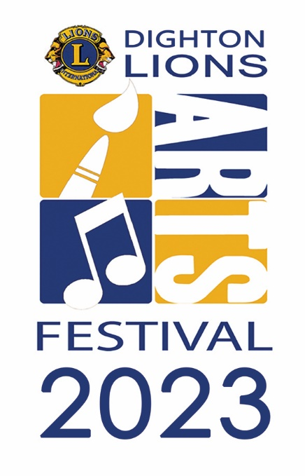
2023 Exhibitor Registration Form

Dighton Lions Club
Eighteenth Annual Dighton Lions Arts Festival
Sunday, November 5, 2023 | 9:00 a.m. to 3:00 p.m.

Araujo Farms and Greenhouses
1522 Williams Street, Dighton

Registration Fee (per space): $100 (due no later September 1, 2023) based on availability.
EARLY BIRD $80.00 by March 1st, 2023

Name: _______________________________________________________________________

Business Name: _____________________________________________________________________

Street : _______________________________________________________________________

City/State/Zip _______________________________________________________________________

Telephone: _________________________ Email:_______________________________________

Web site ___________________________________________________________________________

Registration Details | Quantity | Fee | Amount
Exhibitor Space(s) (8 feet wide by 10 feet deep) |  | $80
Optional Items
Table (8 feet long) |  | $15
Business card size ad in program and ad on web page |  | $25
¼ page ad in program (4.25 inches wide x 5.5 inches high) |  | $60
Total due (please make payable to Dighton Lions Club)

Please provide a brief description of your exhibit. This description will be used in the festival program and web site. See the 2022 descriptions at www.DightonLionsFestivals.org for examples.

____________________________________________________________________________________

____________________________________________________________________________________

____________________________________________________________________________________

____________________________________________________________________________________

Please mail registration form and payment to:
Janice Munroe
1173 Smith Street
North Dighton, MA 02764
DightonLionsArt@gmail.com (508) 813-2080
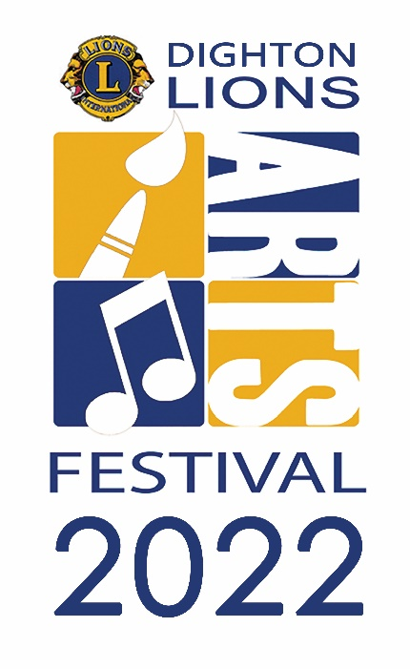
2023 Dighton Arts Festival Exhibitor Registration Form Instructions

The Dighton Lions Club welcomes registrations from artists, crafters, and artisans for the 2023 Dighton Lions Arts Festival. Exhibitors will have an approximately 8’ wide by 10’ deep abutting space in an enclosed greenhouse. Exhibitors need to provide their own display (i.e., easels, print racks, etc.). Limited access to electricity please note that on your application form. A limited number of exhibitor spaces are available.
Please register early to assure your space!

Please contact Jan Munroe at (508) 813-2080 or DightonLionsArt@gmail.com (include Dighton Lions Art Festival in the subject line) with questions or to inquire about space availability. Visit the Dighton Arts Festival web site - DightonLionsFestivals.org - for updates.

Registration Fee: Registration form and fee must be received no later than September 1st, 2023 and is based on availability. Spaces are limited and are not guaranteed.

Tables: A limited number of 8-foot tables are available for rent at $15 each. You may also bring your own table(s). Please keep in mind that the spaces are an abutting space to the vendor on either side of you.

Advertising Space for Exhibitors in the Festival Program. The Dighton Lions Arts Festival program includes the music and activities schedule, list of exhibitors, and advertisements from local businesses that support the festival. We have established space in the program this year for exhibitors to promote their work – either standard size business cards ($25) or ¼ page (4.25 inches wide by 5.5 inches high) ads ($60). The festival program and exhibitors’ advertisement pages will also be available as downloadable documents on DightonLionsFestivals.org.

Exhibit Description. We use the description that you provide on the registration form in the list of exhibitors, the festival program as well as on the festival web site. Please limit your description to 250 characters (including spaces). If you exhibited at the 2022 Dighton Lions Arts Festival, you can review your description on the festival web site – www.DightonLionsFestivals.org .

The Dighton Arts Festival Committee will review each exhibit description for consistency with the purpose of the festival – to provide a place for local and regional artists to display and sell their work in a family-oriented environment that encourages artists of all ages and promotes interest in the arts in our community.

Additional information for exhibitors can be found in the “Information for Exhibitors” document that will be sent to all registered exhibitors and posted on the festival web site.

